**Software to Install**

1. Host: WinSCP
2. Target: CUPS Driver

**Important Steps in this tutorial**

1. Install CUPS Drivers
2. Change CUPS Configuration File
3. Change PAM (Permanent Authentication Module)
4. Configure printers through web interface
5. Select appropriate driver for printer in the installed ones or find ppd file
6. Print File
7. Configure to work with Putty
8. Enable Secure Shell Server

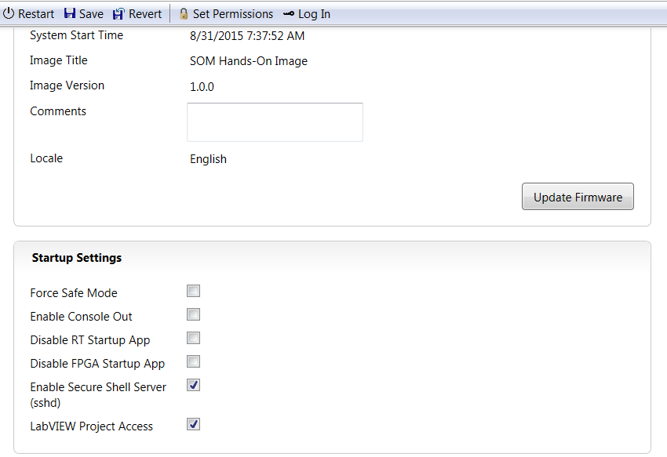

1. Change admin password to something other than empty password (using web client and save it). Remember this you need this. For this tutorial, I will be using **labview** as password.

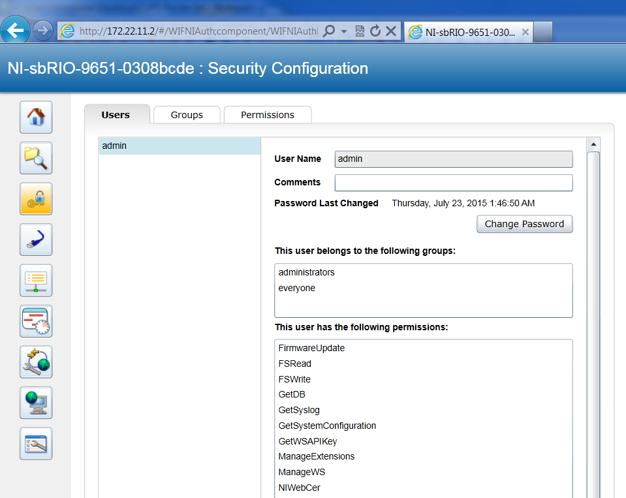

1. Connect with Putty

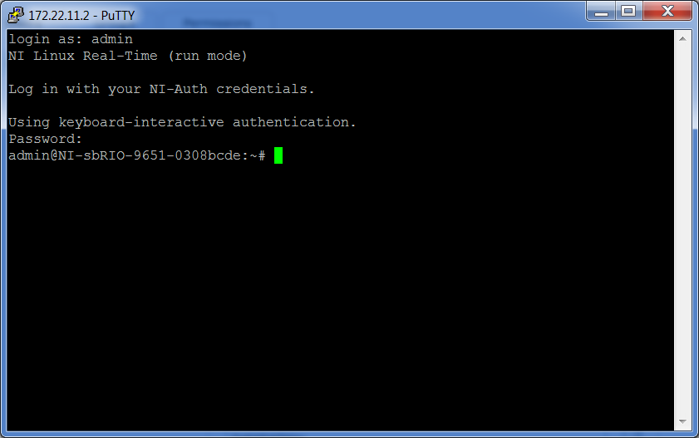

1. Install /Update CUPS Package

**Opkg update**

**Opkg upgrade cups**

Or do

**Opkg update && opkg install cups**

1. Add admin to Printer Group lpadmin, verify admin has been added to lpadmin
2. Linux Command to add admin to printer group

**usermod –a –G lpadmin admin** (Syntax: usermod –a –G lpadmin YOUR-USERNAME)

1. Linux Command to verify

cat /etc/group | grep admin (Syntax: cat /etc/group | grep YOUR-USERNAME)

1. Modify printer Config File
   1. Connect to target using WinSCP
   2. Navigate to /etc/cups
   3. Replace “cupsd.conf” with the file attached to this tutorial using WinSCP
2. Modify Authentication Module
   1. Navigate to /etc/pam.d
   2. Replace “cups” in the folder with modified “cups” file attached
3. Reboot the Target
4. Restart CUPS Server

a )Check if you are at the top

**Command: pwd**

**Expected answer: /**

1. Navigate to the top using cd ..
2. Start/restart the cups server
3. Go to <https://172.22.11.2:631/admin>
4. Click Add Printer

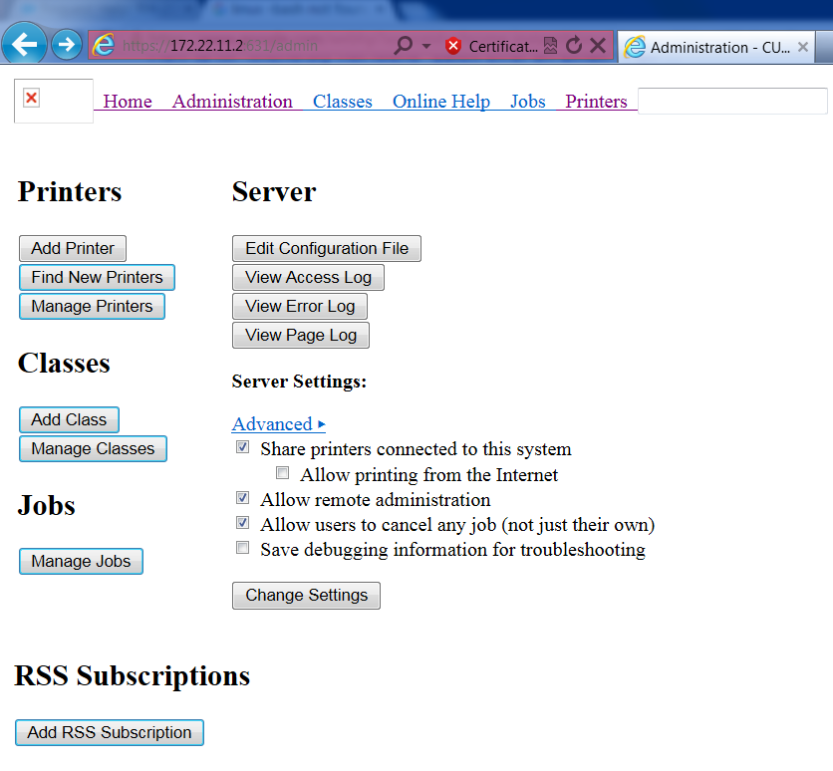

1. Select one of the discovered printers

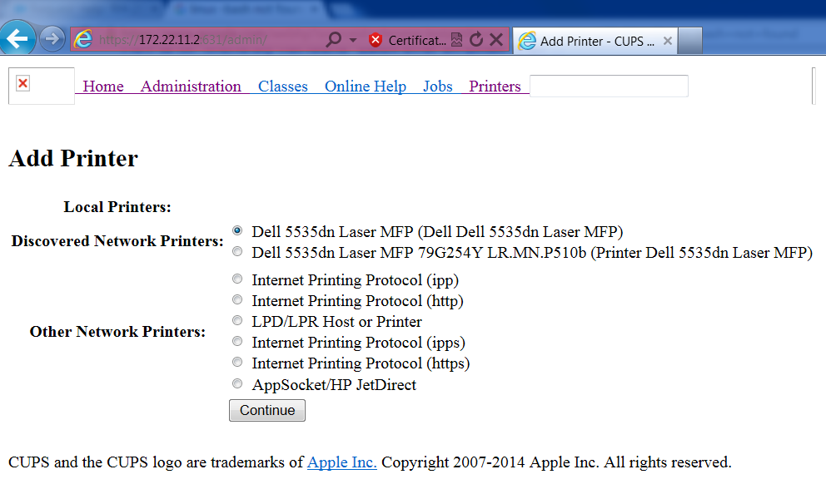

1. Name the printer

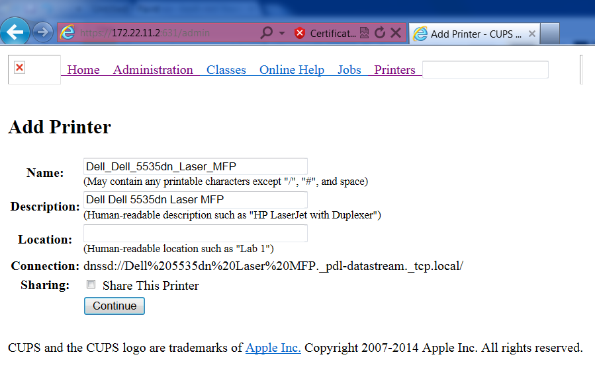

1. **Select Printer Model. If you don’t find printer model, get the PPD for searching on the web.**

**Since the Dell Printer is not listed, we found a PPD File on the web at**

[**http://ecee.colorado.edu/resources/ecehelp/ecedell-1b55.html**](http://ecee.colorado.edu/resources/ecehelp/ecedell-1b55.html)

**Then browse to the downloaded PPD using the Browse button on this page**

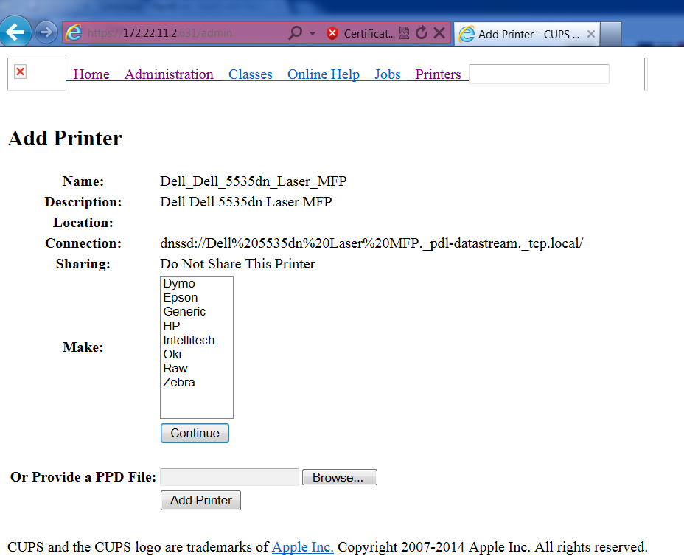

1. Finally you will get page to set printer options
2. To print a file
3. Get list of printers

Command Syntax: lpstat –p

1. Check if there is default printer

Command Syntax: lpstat -d

1. To print a file to default printer

Command Syntax: lp filename

1. To print a file to specific printer

Command Syntax: lp –d printer filename

1. To set default printer

Lpoptions –d printer

Sample commands:

1. Set Default printer

lpoptions -d Printer_Dell_5535dn_Laser_MFP

1. Navigate to test file directory

cd /usr/share/cups/ipptool

1. Print Test file

lp testfile.ps

Note: At this point, I was able to get *.ps file working. You have to follow additional steps to print text file.